

THIORA EMMANUEL
BSCCS/2024/56022
BIT4138
ADVANCED CRYPTOGRAPHY
MR MICHAEL NYORO
PROJECT TITLE: SECURE FILE ENCRYPTION AND AUTHENTICATION SYSTEM
TECHNOLOGIES:
- Python
- Visual Studio code
- Cryptography library
- Github
- Open SSL

Github link
https://github.com/thiorah/cryptography.git

TABLE OF CONTENTS
 1
WEEK 1 – Cryptography environment setup 4
Python & VS Code installation screenshots 4
Cryptography library installation 5
Encryption script running 5
Github initialization 6
WEEK 2 – Classical cryptography and cipher design 7
Vigenere cipher 7
Encryption and Decryption 8
User Input Validation Interface 8
Cipher Testing Results 9
WEEK 3 – Stream Ciphers and Randomness 10
LSFR Generator 10
Pseudorandom Sequence Output 10
Statistical Randomness Testing 11
RC4 Stream Cipher Simulation 11
Encryption Performance Results 12
WEEK 4 – Block cipher design and AES 13
AES Encryption Script 13
Key Generation Process 14
File Encryption Demonstration 14
Decryption Results 15
AES Performance Testing 15
WEEK 5 – RSA 17
RSA Key pair generation 17
PUBLIC KEY ENCRYPTION PROCESS 17
PRIVATE KEY DECRYPTION RESULTS 18
SECURE MESSAGE TRANSMISSION 18
RSA TESTING & VALIDATION 19
WEEK 6 – SYMMETRIC CIPHERS 20
SHA-256 Hash Generation 20
Password hashing System 20
Login Authentication Workflow 21
Hash Verification Results 21
WEEK 7 - BLOCK CIPHER CRYPTANALYSIS 22
Digital Signature Generation 22
Signature Verification Process 23
Secure Document Validation 23
WEEK 8 – PUBLIC KEY INFRASTRUCTURE 24
Definition of Diffie–Hellman 24
How the Protocol Works 24
The Discrete Logarithm Problem 25
Applications in TLS/SSL 26
Security Challenges and Possible Solutions 26
Conclusion 27
References 28
WEEK 9 – RSA CRYPTOSYSTEM 28
Key generation of RSA encryption system 28
Encryption of text 29
Decryption of the text 29
Digital signature of the encryption 30
Miller-Rabin test 30
WEEK 10 – ElGamal Cryptosystem 31
Key generation on Elgamal cryptosystem 31
Encryption of text 32
Decryption of text 32
Randomness demonstration 33
RSA vs ElGamal cryptosystems 33

WEEK 1 – Cryptography environment setup

Python & VS Code installation screenshots
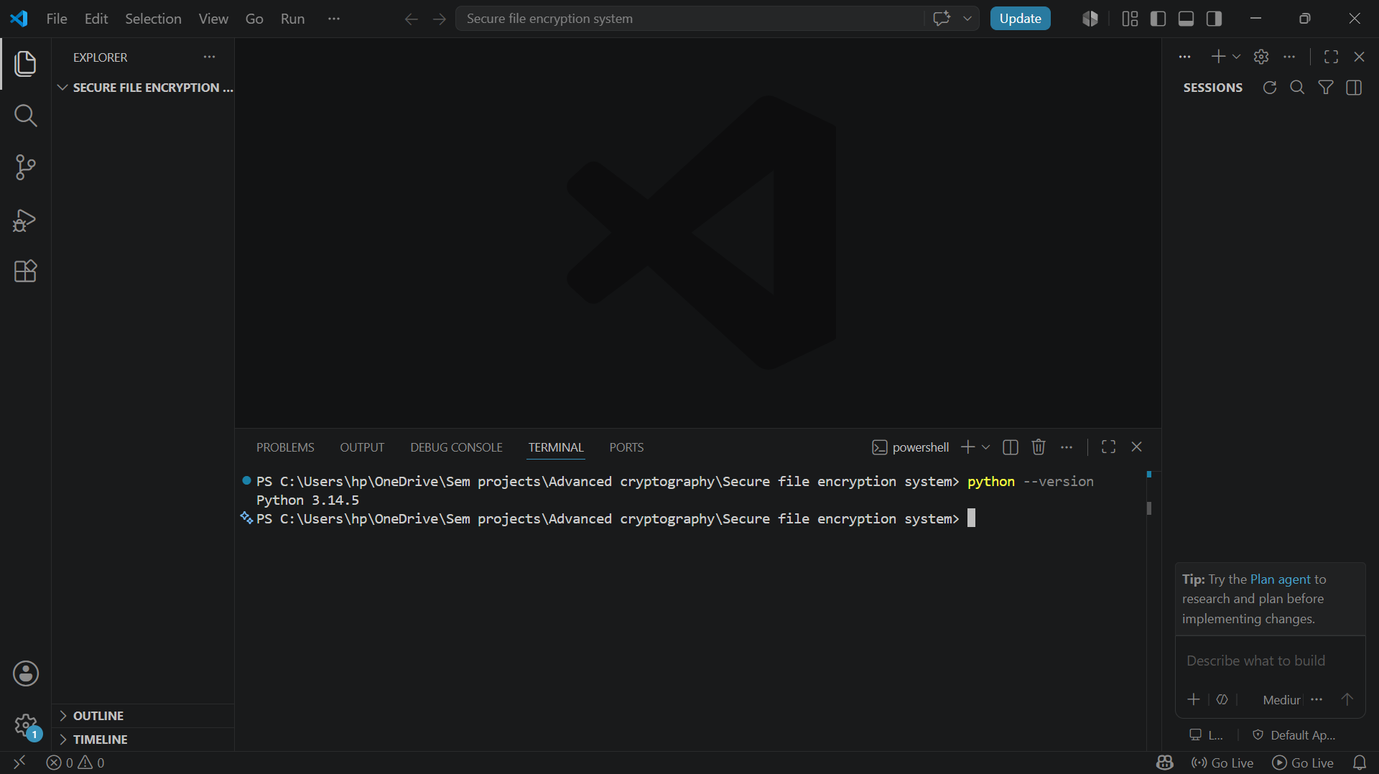
Fig 1.1 python and VS code installation

Cryptography library installation
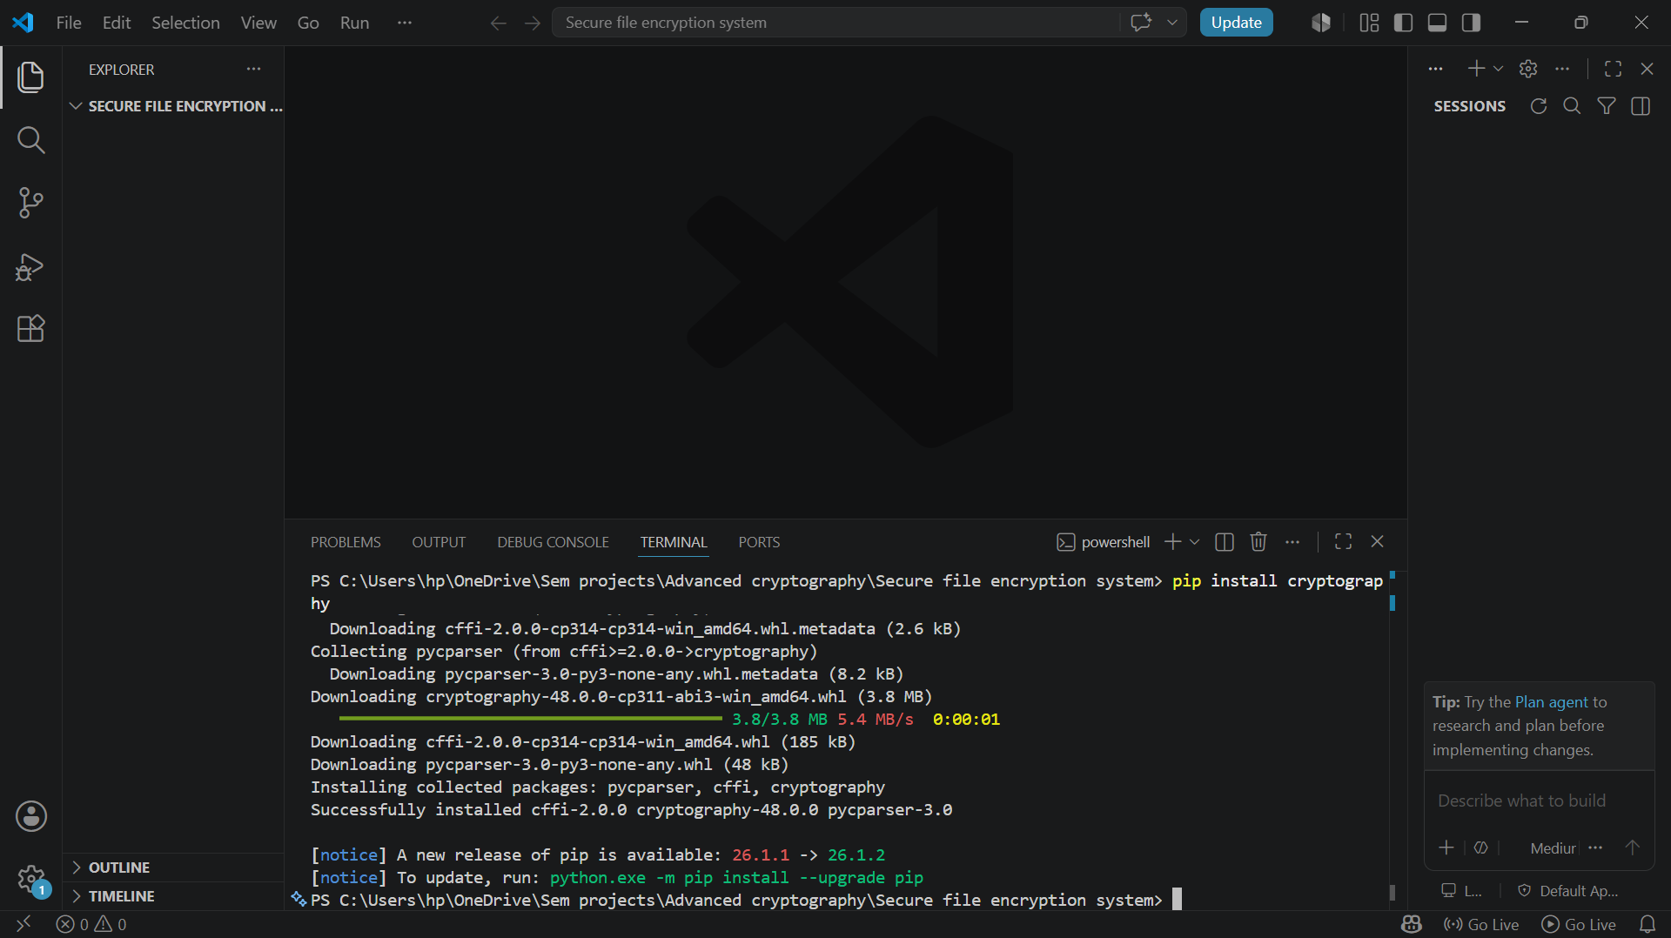
Fig 1.2 cryptography library installation

Encryption script running
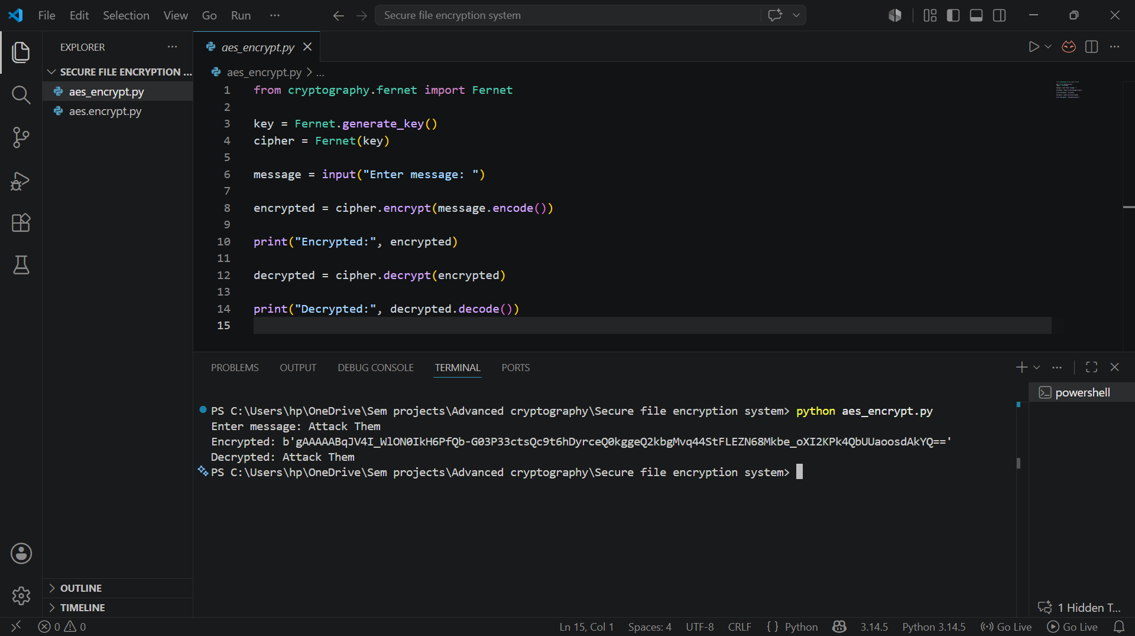
Fig 1.4 encryption script

Github initialization
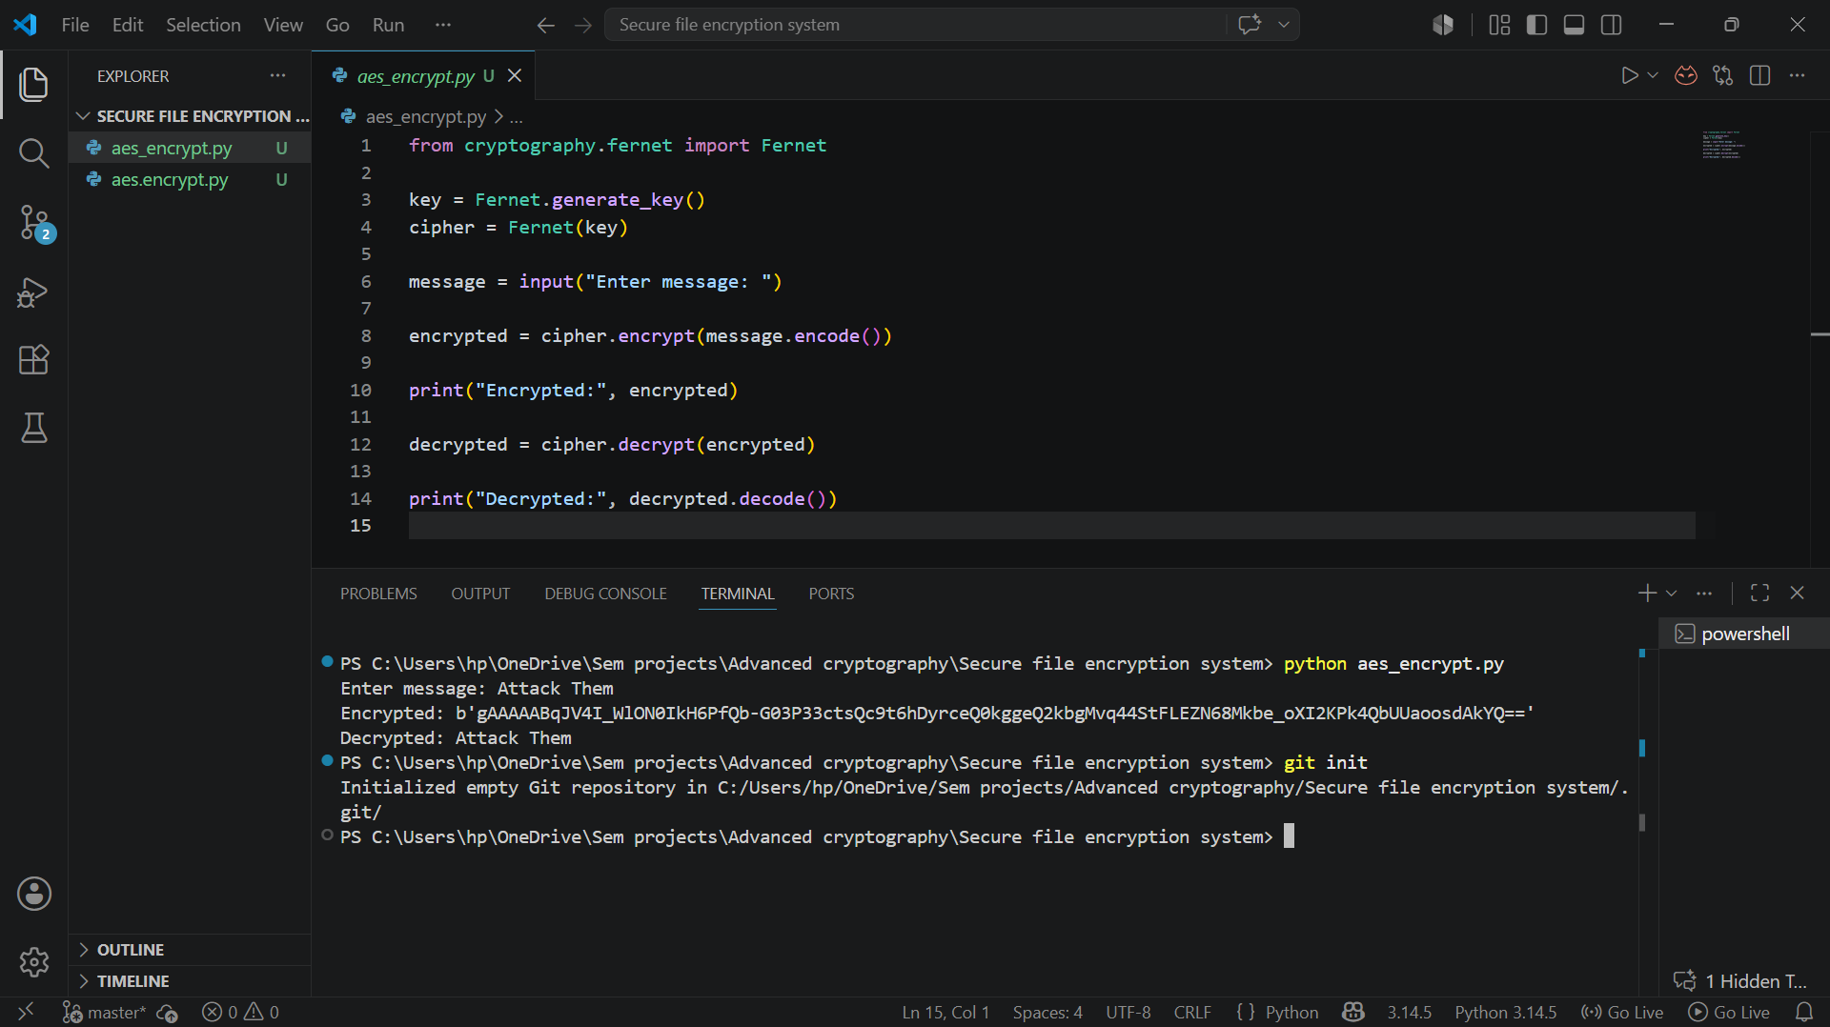
Fig 1.5 Github initialized

Reflection:
This week I configured Python, VS Code, OpenSSL, and cryptography libraries. I learned how development environments are prepared for secure cryptographic implementations and version control using GitHub.

WEEK 2 – Classical cryptography and cipher design
Ceaser Cipher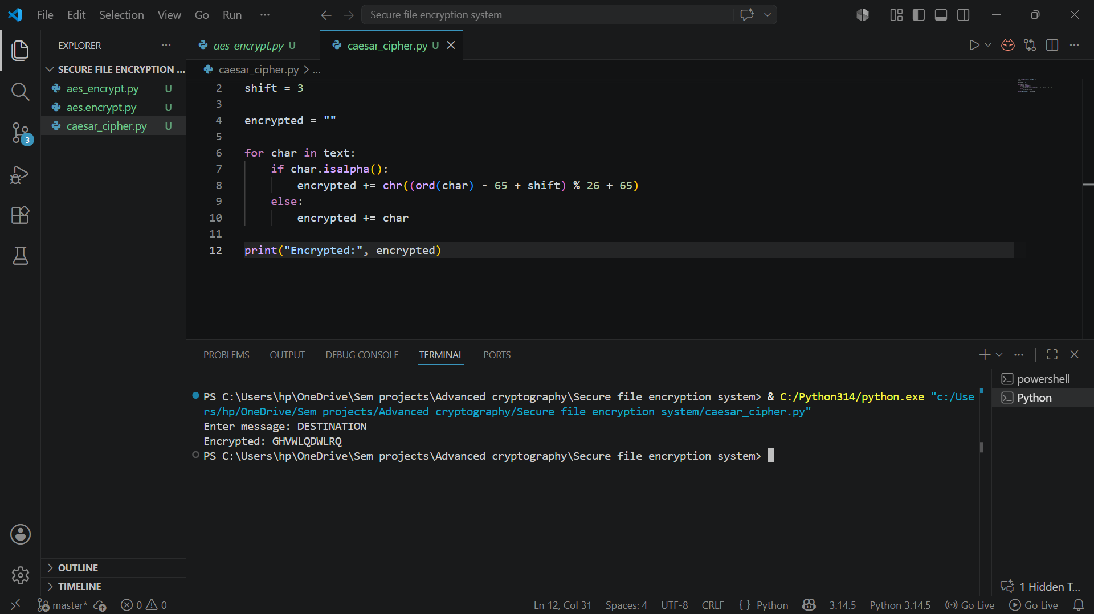
Fig 2.1 ceaser cipher

Vigenere cipher
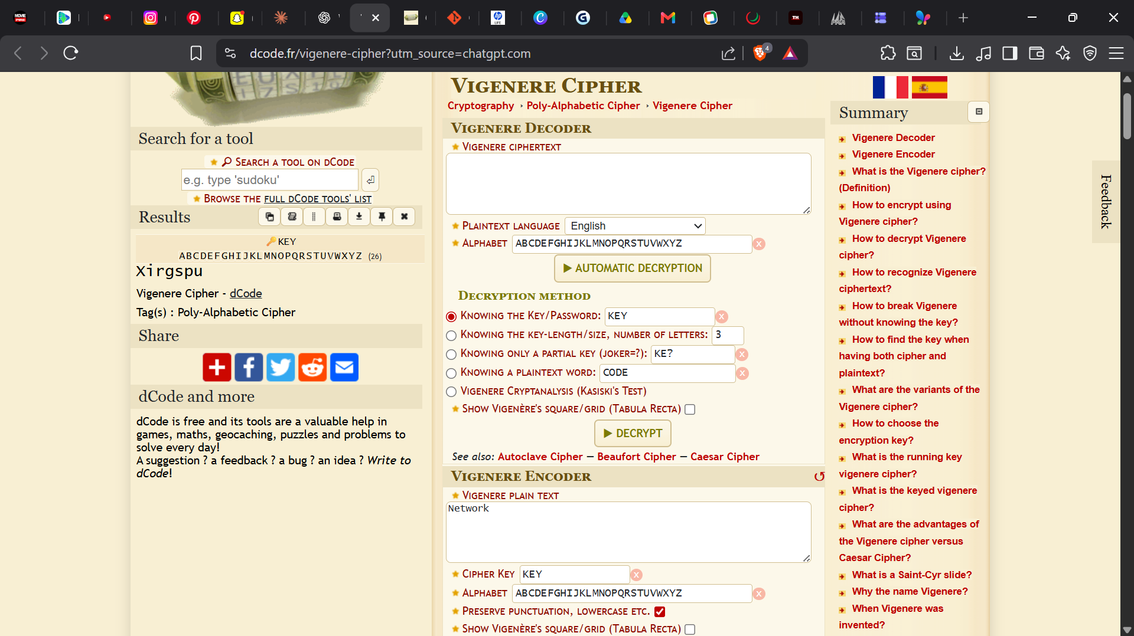

Encryption and Decryption
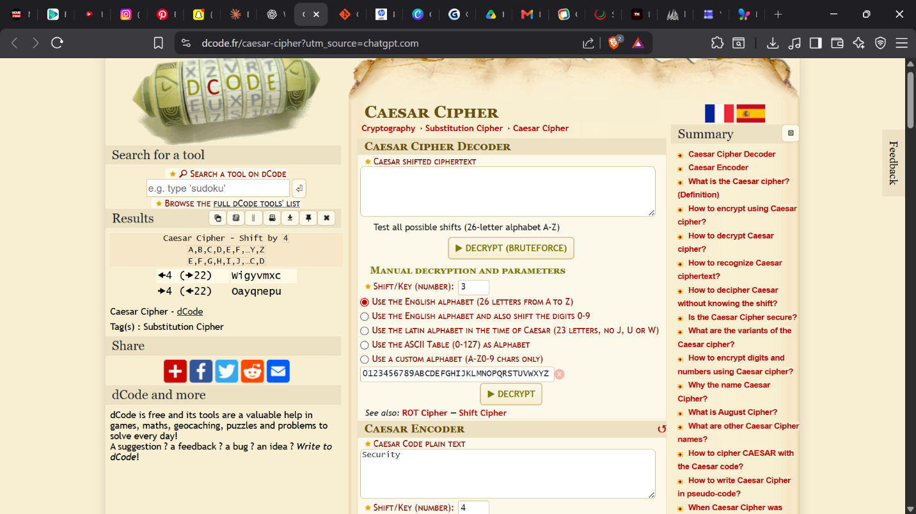
Fig 2.3 encryption and decryption

User Input Validation Interface
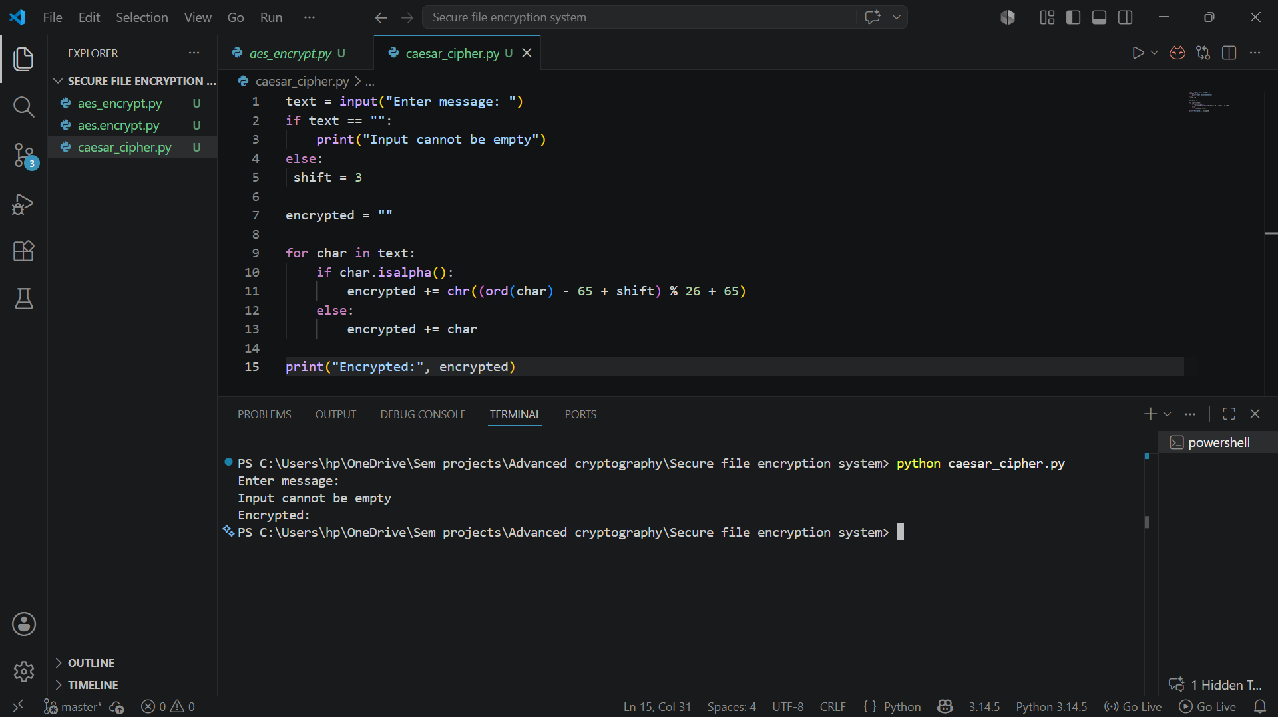
Fig 2.4 user input validation

Cipher Testing Results
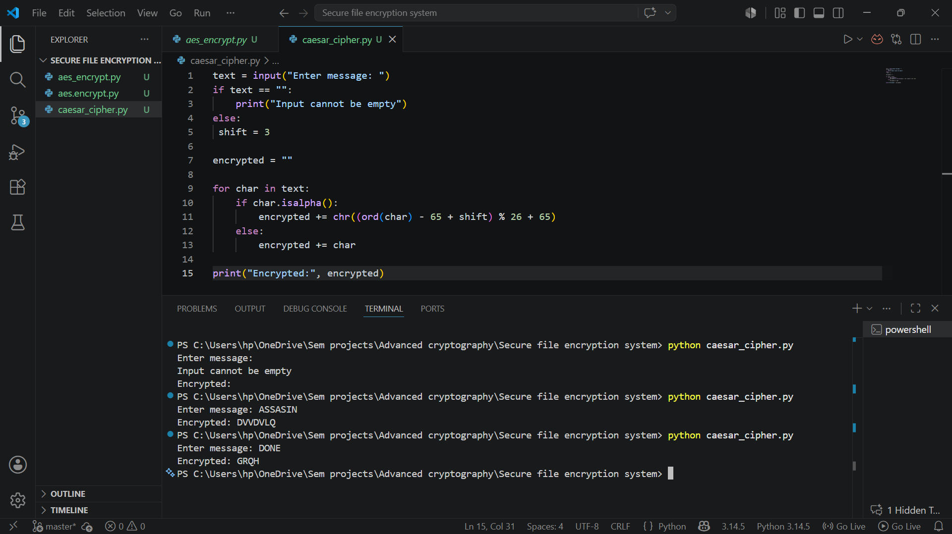
Fig 2.5 Cipher testing results of different plaintext

Reflection
This week I implemented Caesar Cipher and Vigenère Cipher encryption techniques using Python. I learned how classical encryption algorithms use keys to secure messages and understood the importance of input validation and encryption testing in cryptographic systems.

WEEK 3 – Stream Ciphers and Randomness

LSFR Generator
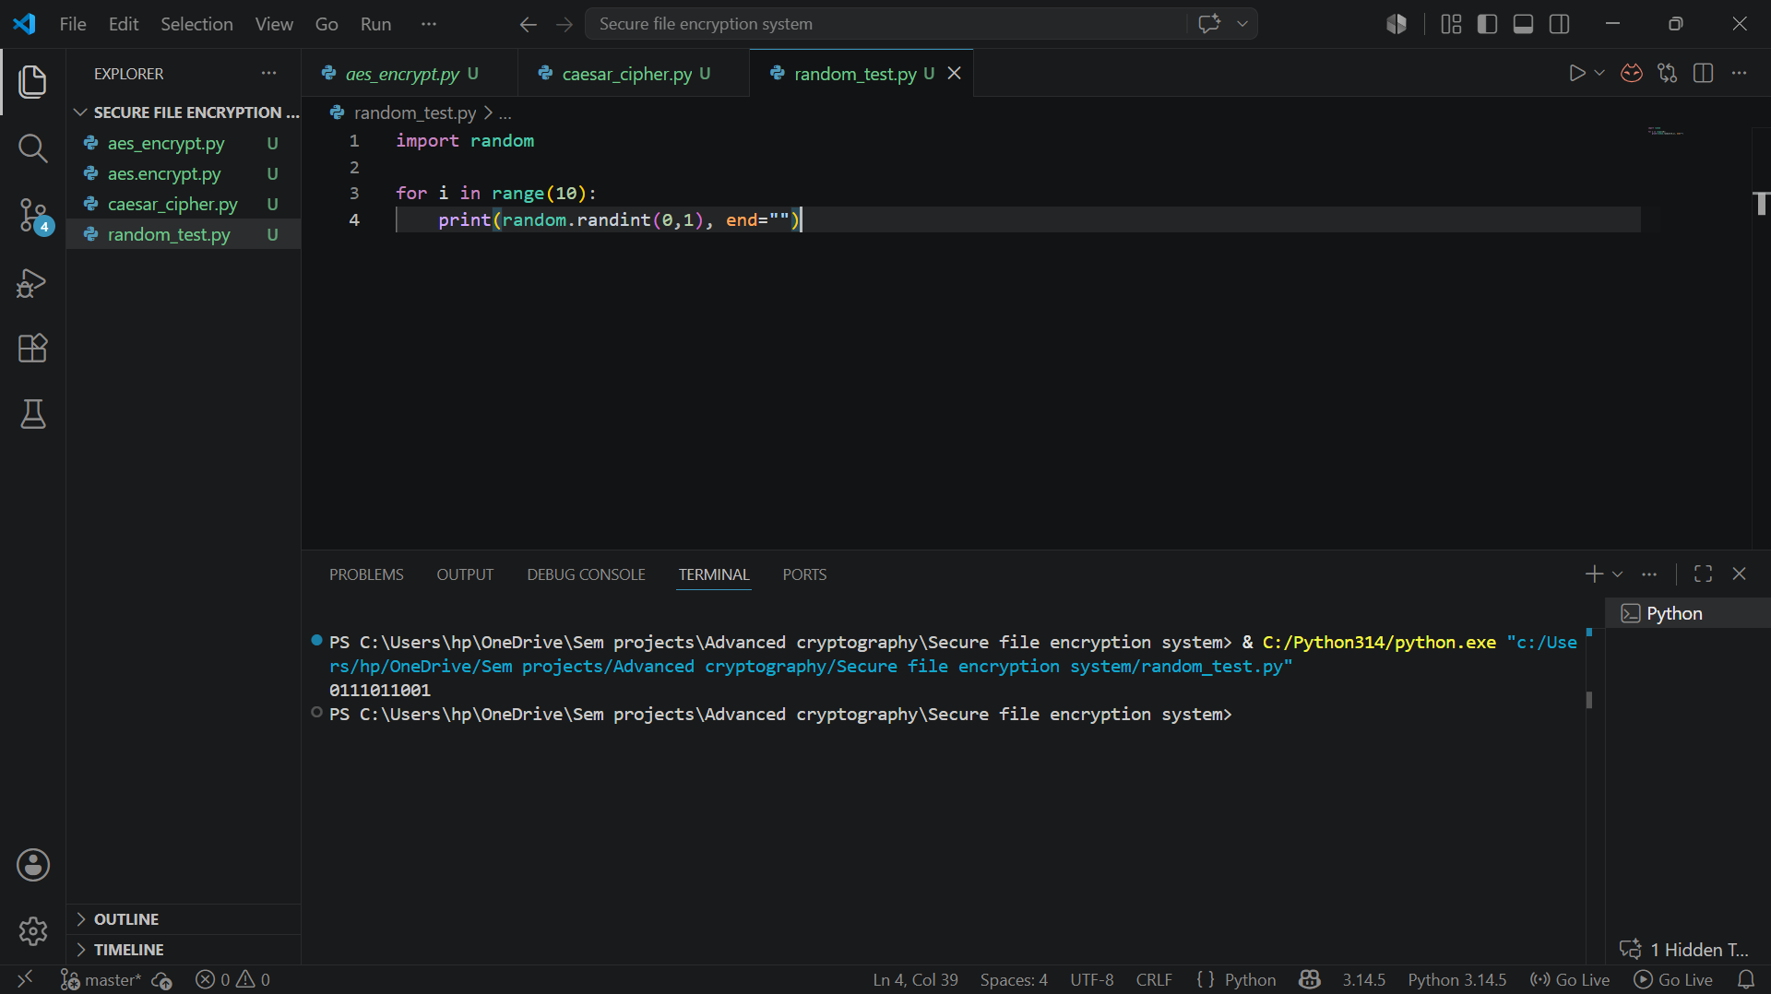
Fig 3.1 Pseudorandom binary sequence generation for stream cipher simulation.

Pseudorandom Sequence Output
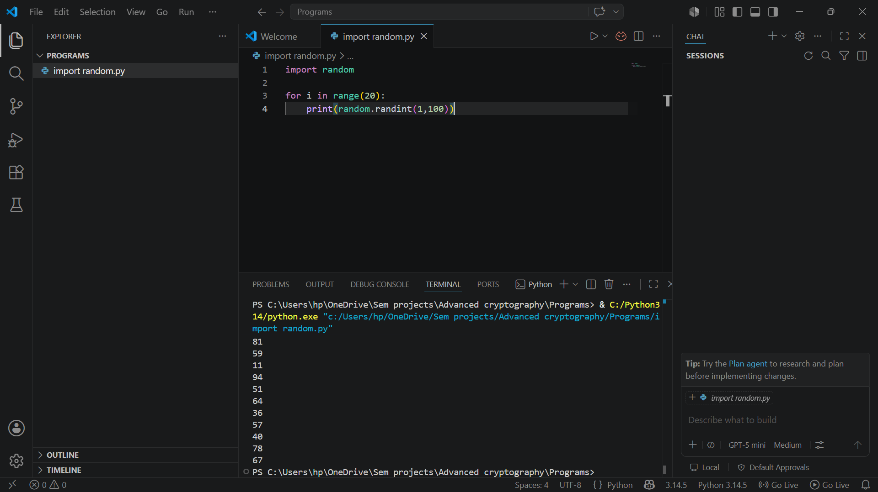
Fig 3.2 Generated pseudorandom sequences demonstrating randomness

Statistical Randomness Testing
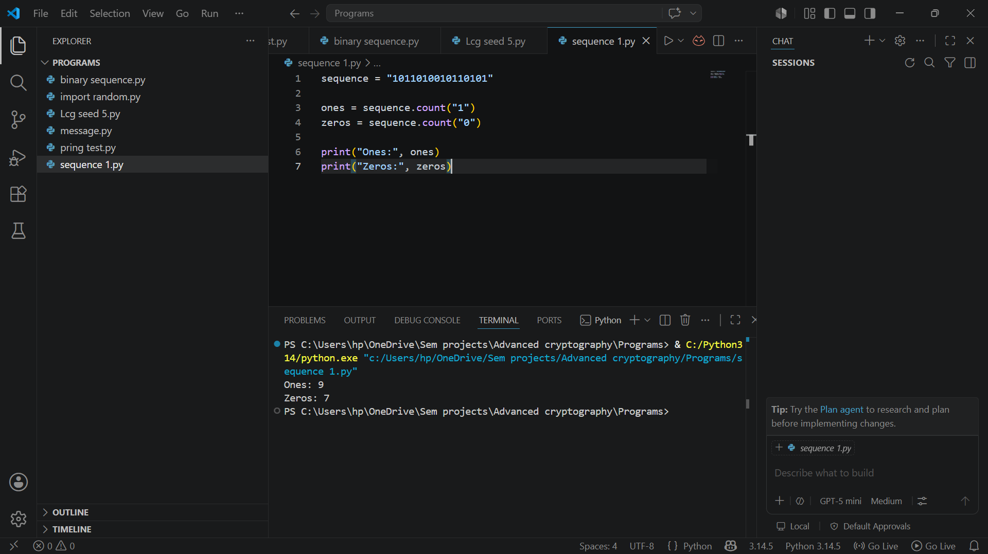
Fig 3.3 Statistical randomness analysis performed on generated binary sequences.

RC4 Stream Cipher Simulation
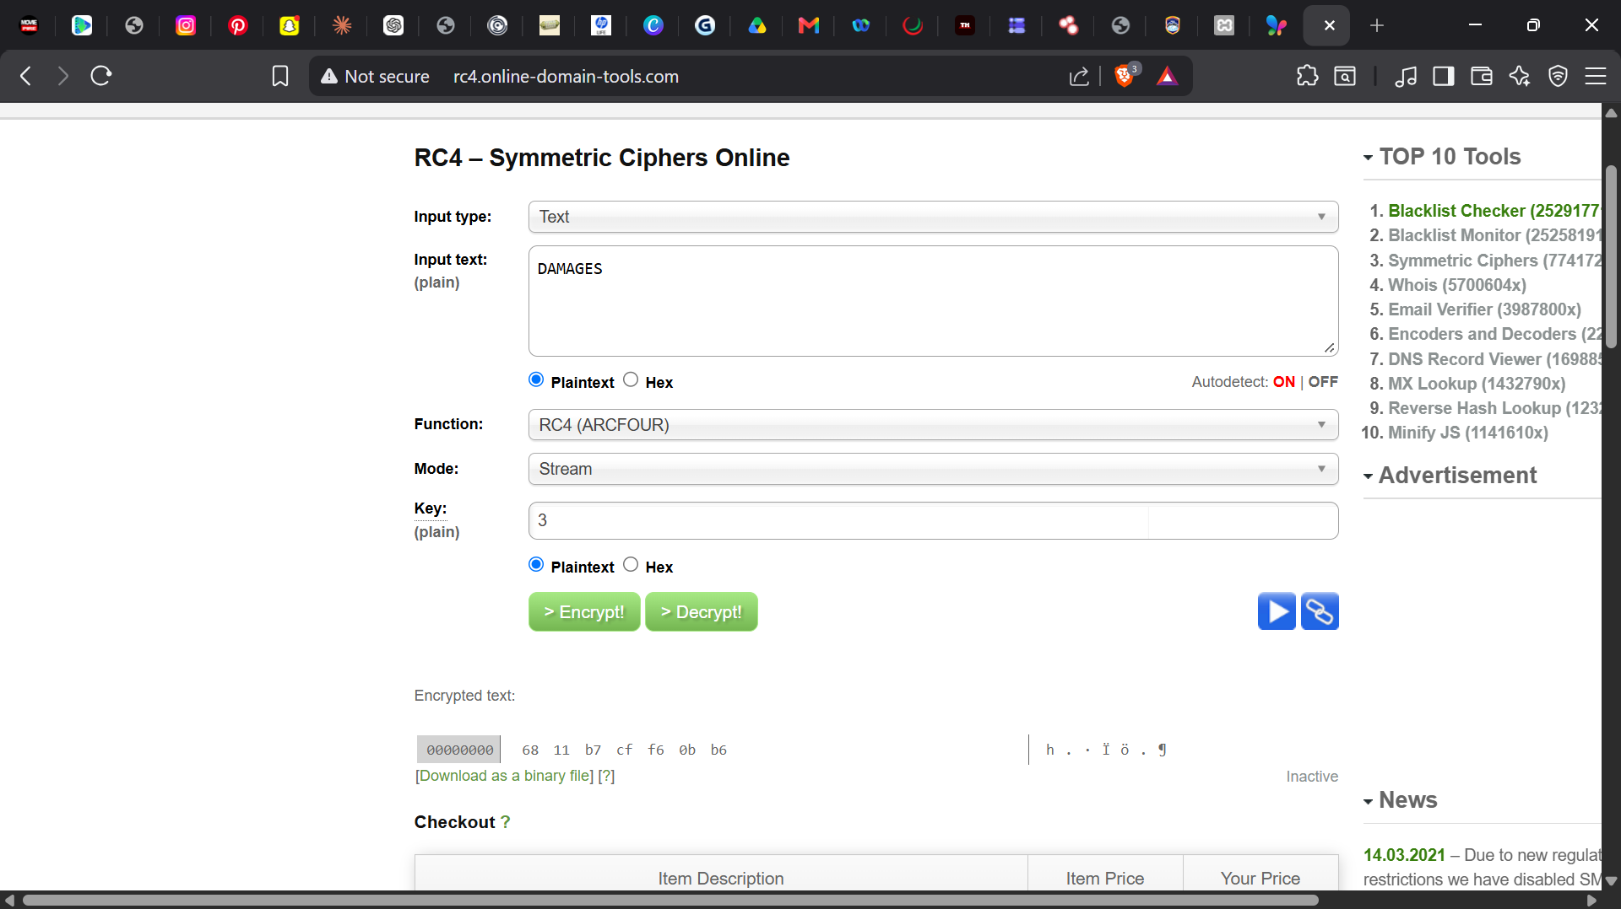
Fig 3.4 RC4 stream cipher simulation

Encryption Performance Results
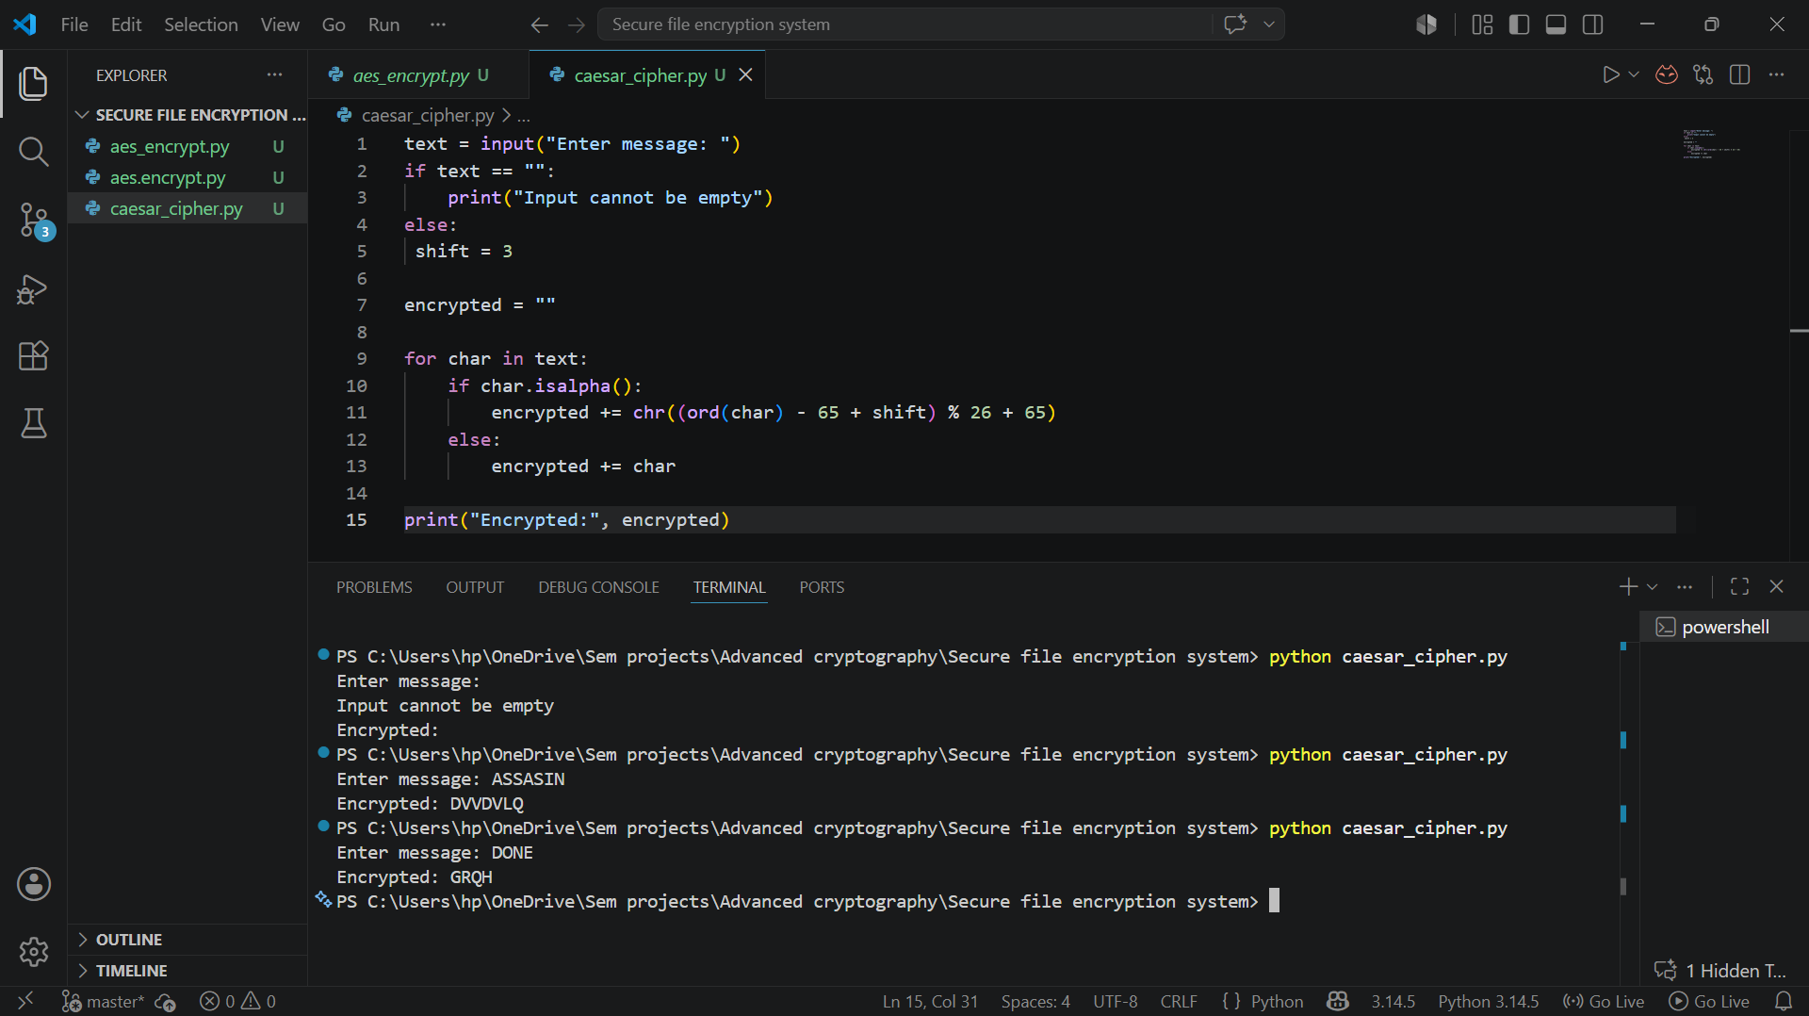

Reflection
This week I explored stream cipher concepts and pseudorandom sequence generation. I performed randomness testing on generated binary outputs and understood the importance of randomness in securing cryptographic communication systems and stream encryption workflows.

WEEK 4 – Block cipher design and AES

AES Encryption Script
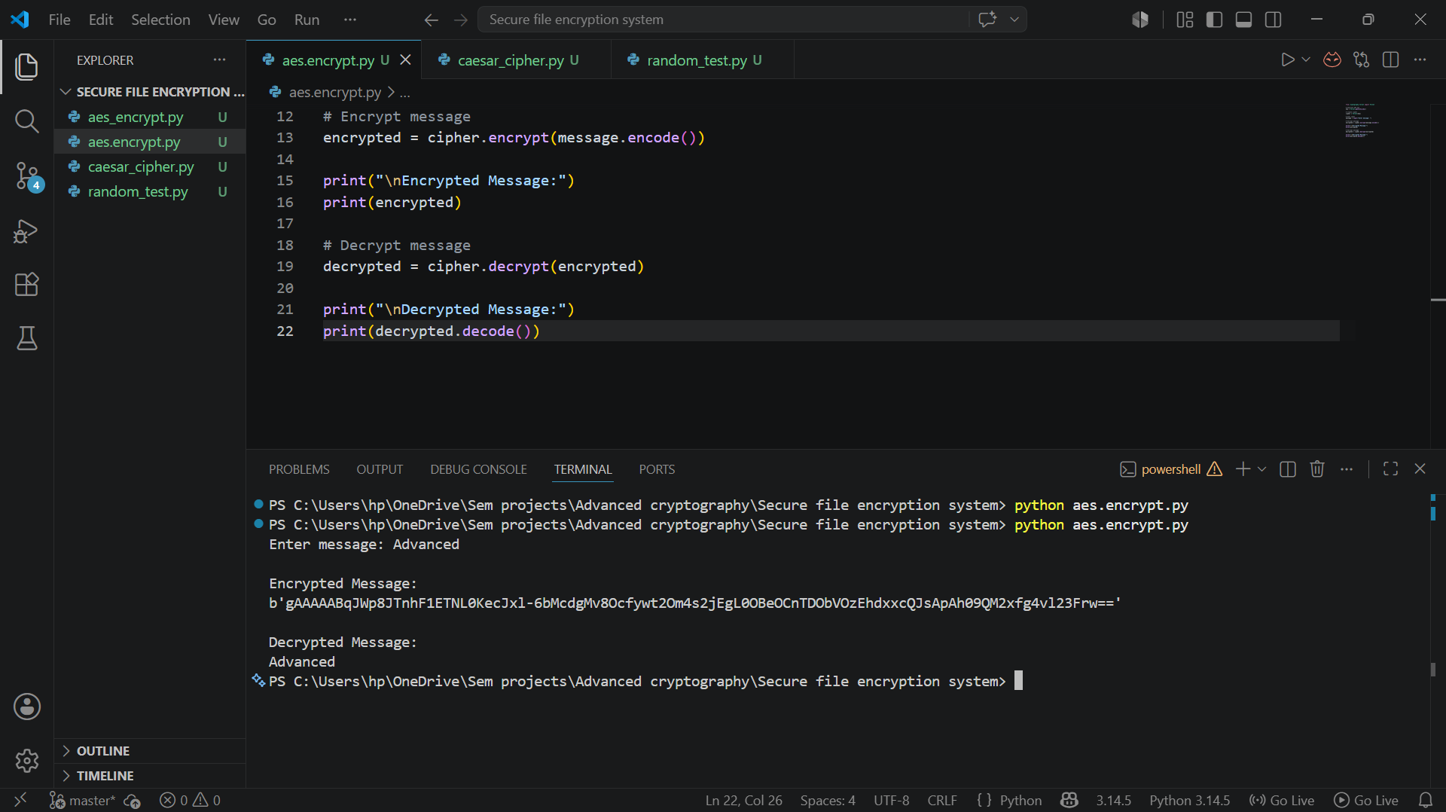
Fig 4.1 AES encryption script implementing symmetric encryption

Key Generation Process
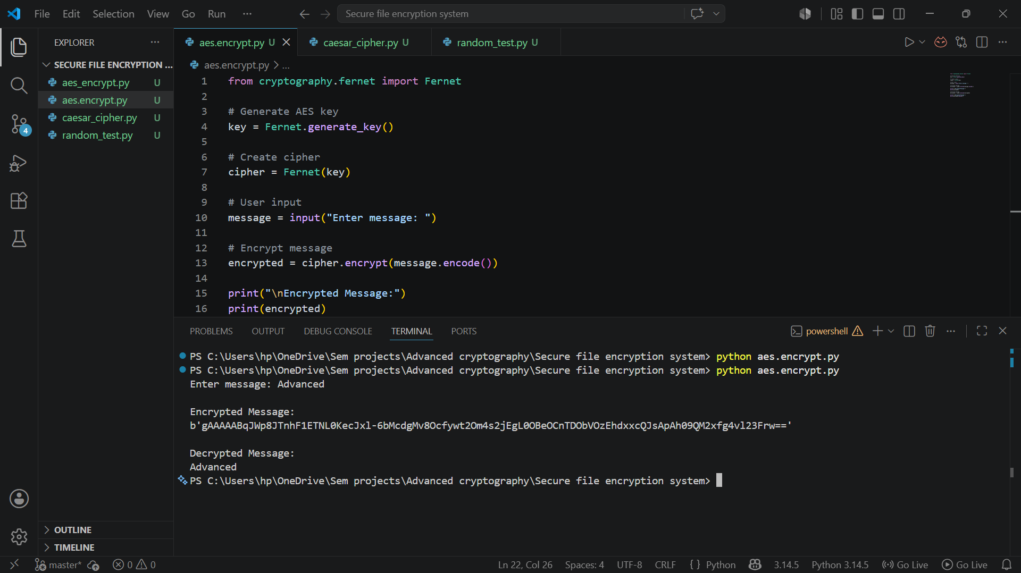

File Encryption Demonstration

Fig 4.3 Successful encryption of plaintext message using AES symmetric encryption

Decryption Results

Fig 4.4 Successful decryption restoring original plaintext message using AES.

AES Performance Testing
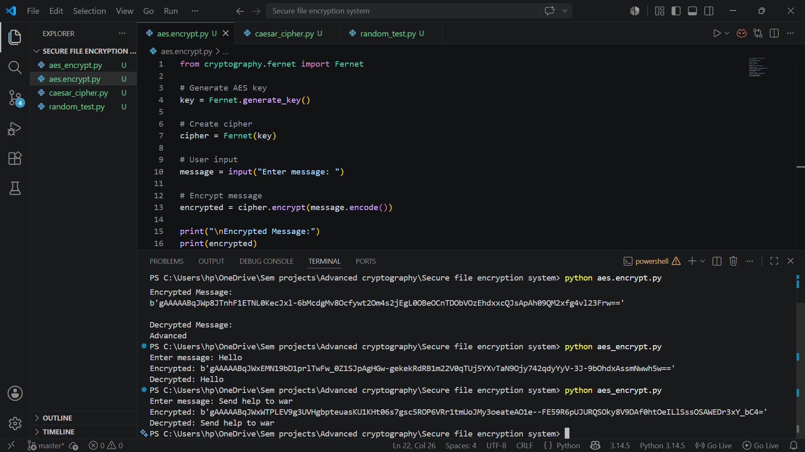
Fig 4.5 AES encryption performance testing using different plaintext inputs and message lengths.

Reflection
This week I implemented AES symmetric encryption using Python cryptography library. I successfully generated encryption keys, encrypted plaintext messages, and restored them through decryption while understanding the importance of secure key handling.

WEEK 5 – RSA

RSA Key pair generation
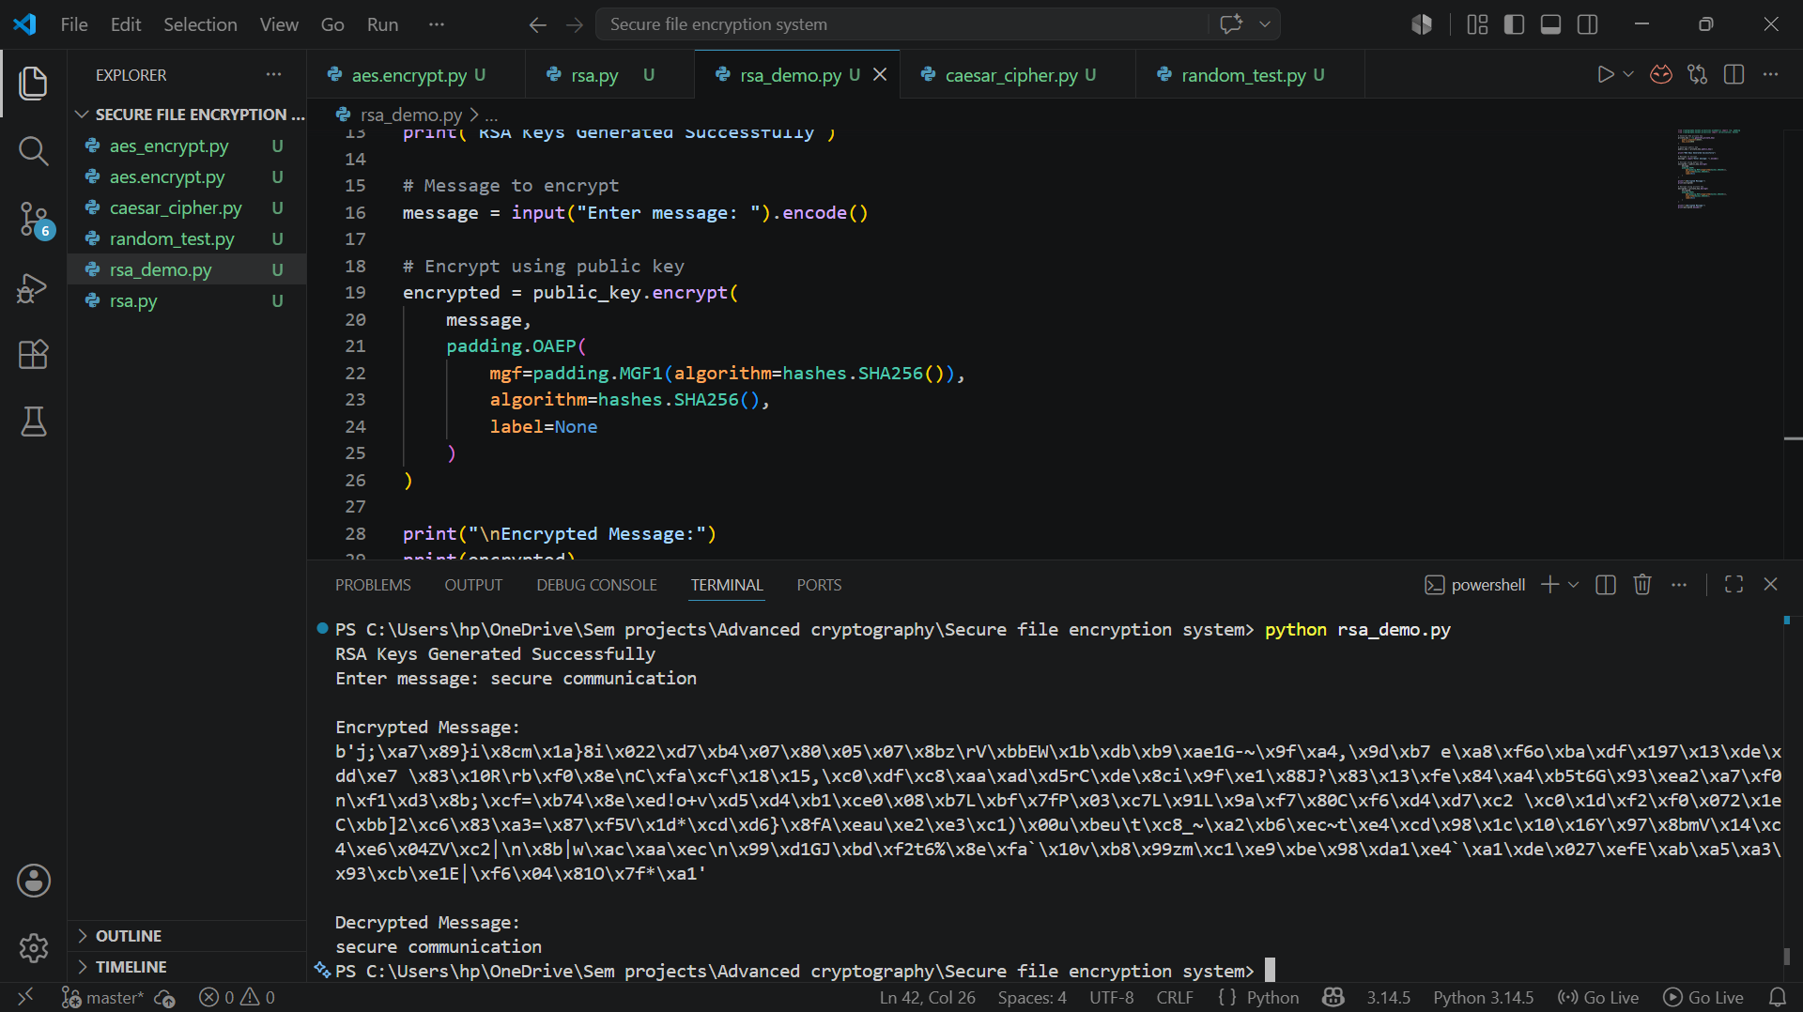
Fig 5.1 RSA public and private key pair successfully generated

PUBLIC KEY ENCRYPTION PROCESS


PRIVATE KEY DECRYPTION RESULTS

Fig 5.3 Successful private key decryption restoring original plaintext message

SECURE MESSAGE TRANSMISSION
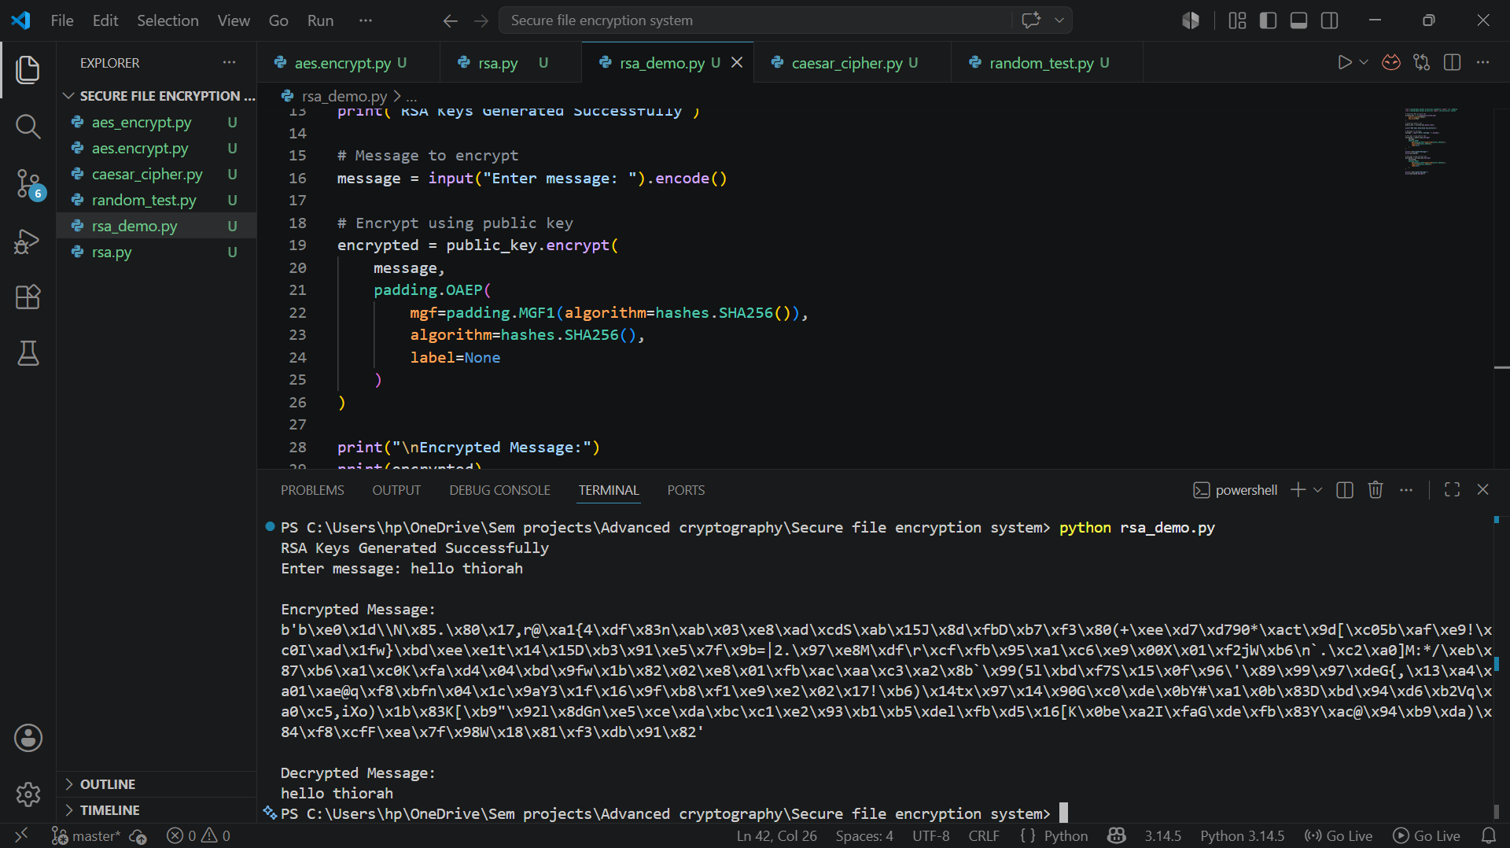
Fig 5.4 Secure message transmission workflow using RSA public and private key encryption.

RSA TESTING & VALIDATION
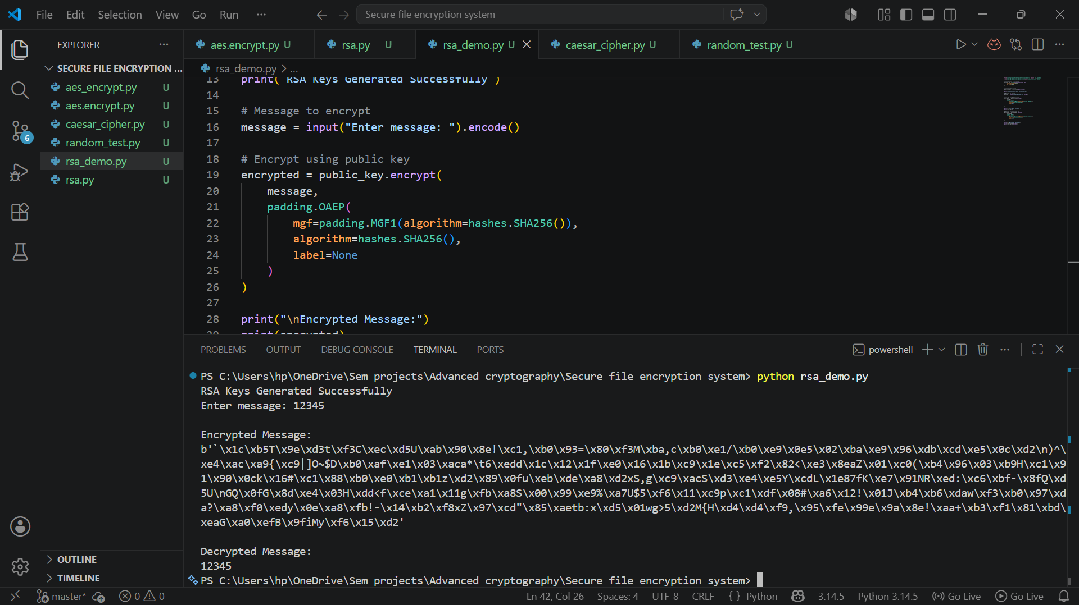
Fig 5.5 RSA encryption testing and validation using different plaintext messages

Reflection
This week I implemented RSA asymmetric encryption using public and private keys. I successfully encrypted and decrypted messages while understanding the importance of secure key management and asymmetric cryptography.

WEEK 6 – SYMMETRIC CIPHERS

SHA-256 Hash Generation
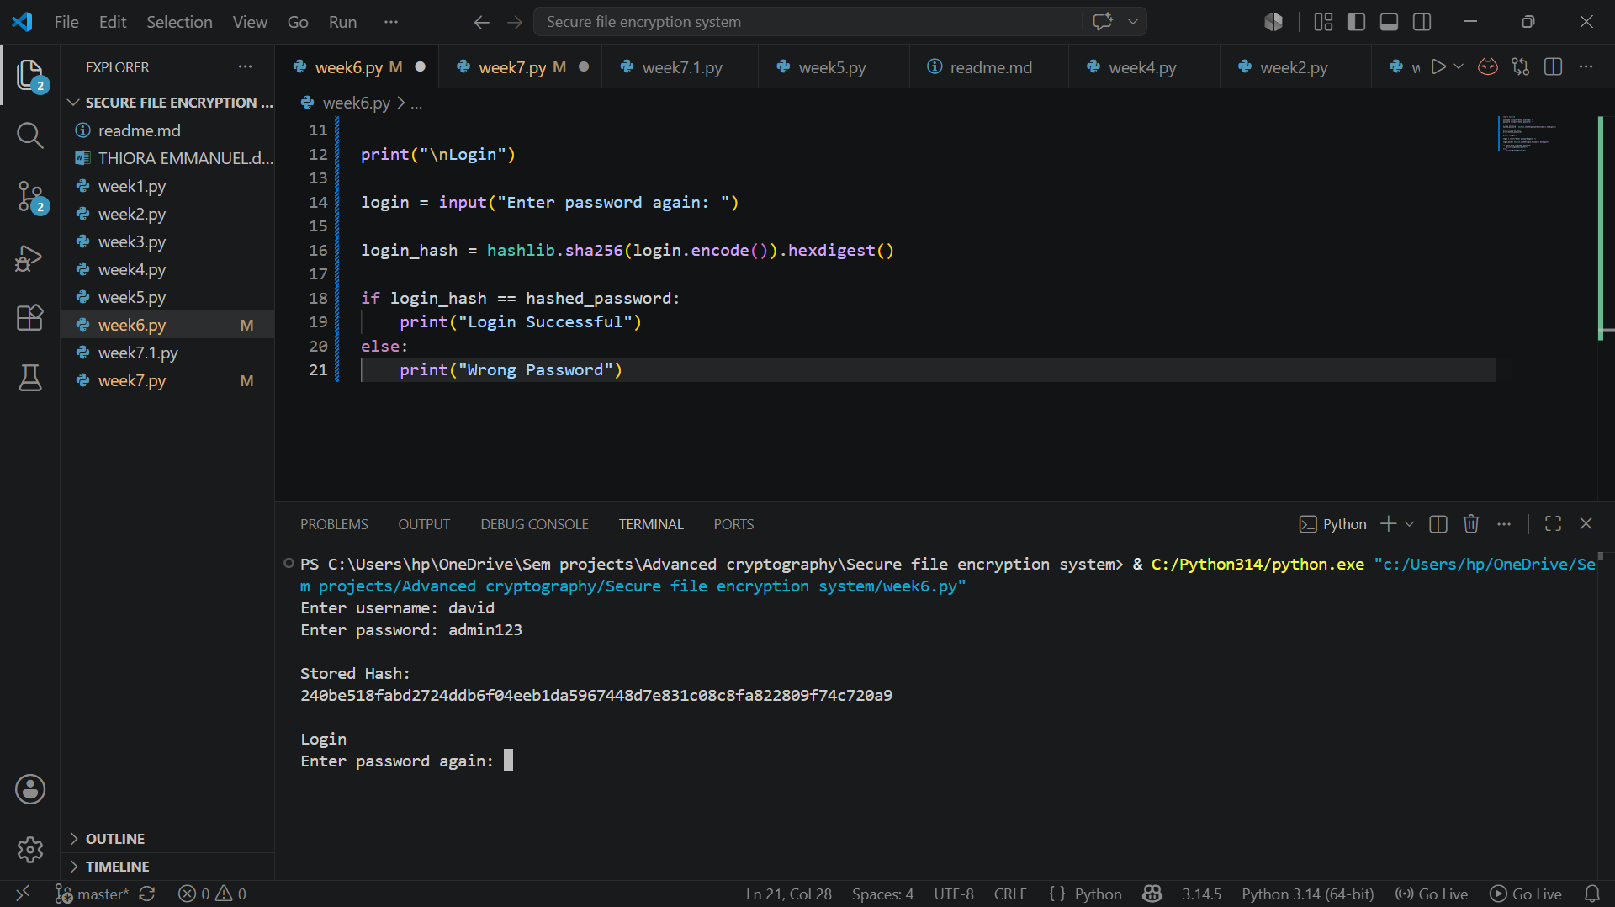

Password hashing System
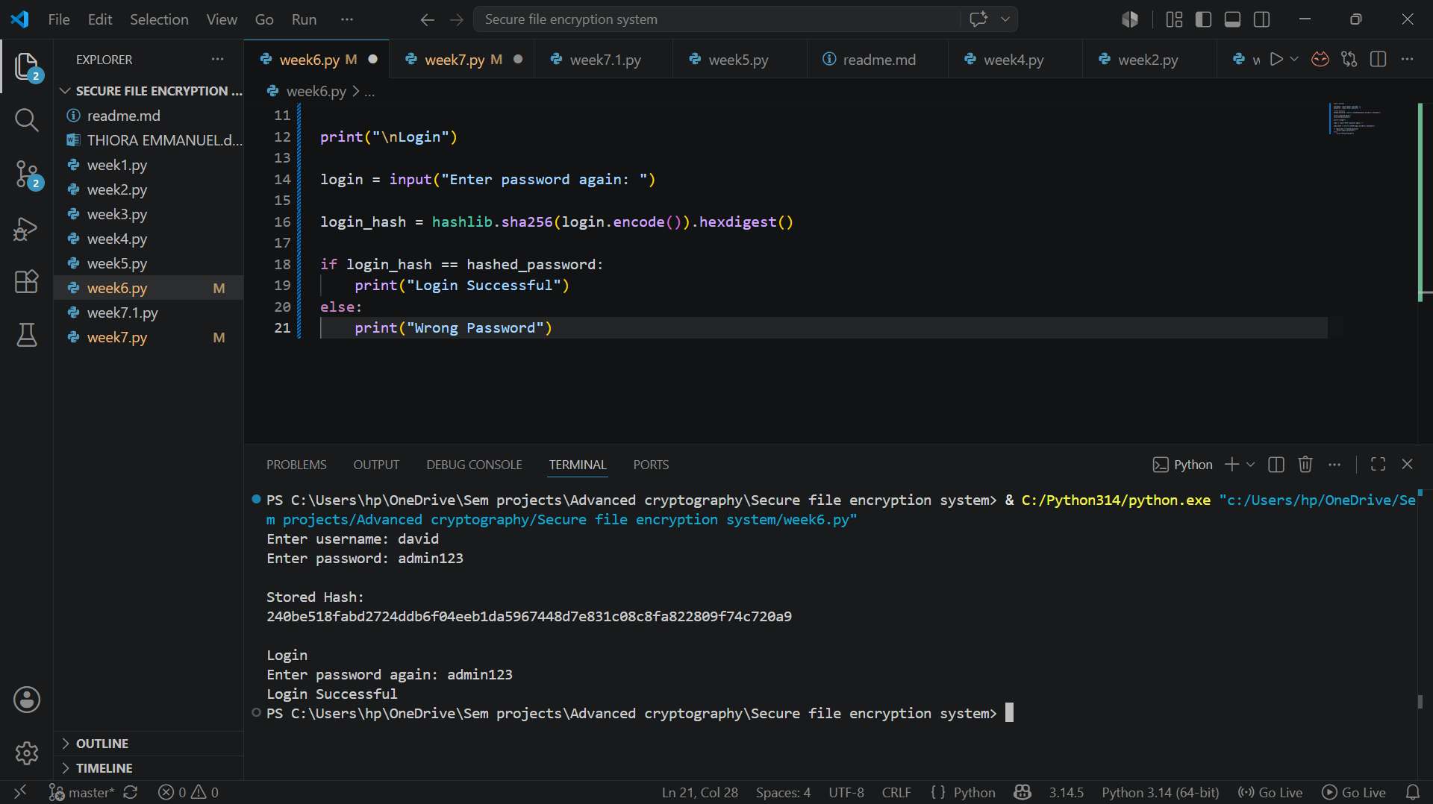

Login Authentication Workflow


Hash Verification Results


Reflection
SHA-256 hashing was used to protect passwords without storing plain text. I implemented password verification by comparing hashes and confirmed successful authentication and failed login attempts through testing.

WEEK 7 - BLOCK CIPHER CRYPTANALYSIS

Digital Signature Generation
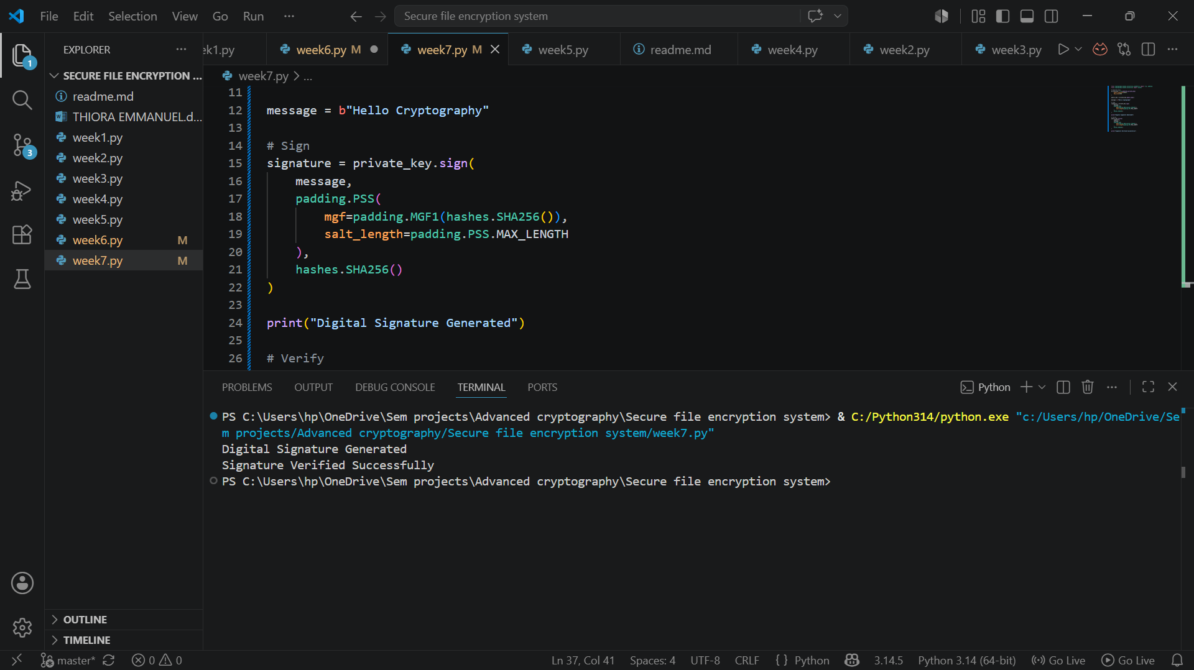

Signature Verification Process


Secure Document Validation


Reflection
I implemented RSA digital signatures to verify data authenticity and integrity. The program successfully generated a signature and verified it using the public key, demonstrating secure authentication.

WEEK 8 – PUBLIC KEY INFRASTRUCTURE
The Role of Diffie–Hellman Key Exchange in Modern Internet Security

Definition of Diffie–Hellman
The Diffie–Hellman (DH) Key Exchange is a cryptographic protocol that allows two parties who have never met and share no prior secret to jointly establish a common secret key over a communication channel that an adversary may be freely observing. Published in 1976 by Whitfield Diffie and Martin Hellman in their paper "New Directions in Cryptography," it was the first practical method for solving the key-distribution problem, which had previously required a secure, out-of-band channel to exchange keys before encrypted communication could begin. Diffie-Hellman itself does not encrypt data; rather, it produces a shared secret that is subsequently used to derive symmetric session keys (for example, AES keys) used by other algorithms to encrypt the actual traffic.
The security of the protocol does not depend on keeping the exchange method secret, but on the mathematical difficulty of a specific problem — the Discrete Logarithm Problem — which is explored in Section 3. Because of this property, Diffie–Hellman is described as a public-key (asymmetric) technique, even though its output is a shared symmetric key rather than a public/private key pair.

How the Protocol Works
The classical (finite-field) Diffie–Hellman exchange proceeds as follows:
- Public agreement: The two parties, conventionally called Alice and Bob, publicly agree on a large prime number p and a base (generator) g, where g is a primitive root modulo p. These values are not secret and may even be standardized and reused.
- Private key selection: Alice privately and randomly chooses a secret integer a; Bob privately chooses a secret integer b. Neither value is ever transmitted.
- Public value exchange: Alice computes A = gᵃ mod p and sends A to Bob. Bob computes B = gᵇ mod p and sends B to Alice. An eavesdropper on the channel can see p, g, A, and B, but not a or b.
- Shared secret computation: Alice computes the shared secret as S = Bᵃ mod p. Bob computes S = Aᵇ mod p. Both calculations yield the same value because (gᵇ)ᵃ mod p = (gᵃ)ᵇ mod p = g^(ab) mod p.
- Key derivation: The shared value S is then passed through a key-derivation function (e.g., HKDF) to produce symmetric session keys used for encryption and message authentication.
A small numerical illustration: let p = 23 and g = 5. If Alice chooses a = 6, she sends A = 5⁶ mod 23 = 8. If Bob chooses b = 15, he sends B = 5¹⁵ mod 23 = 19. Alice then computes S = 19⁶ mod 23 = 2, and Bob computes S = 8¹⁵ mod 23 = 2. Both arrive at the shared secret 2, despite never transmitting a or b. Real-world implementations use primes hundreds of digits long — typically 2048 bits or more — to make the underlying problem computationally infeasible to reverse.
Modern deployments almost always use Elliptic-Curve Diffie–Hellman (ECDH), which replaces modular exponentiation over integers with scalar point multiplication on an elliptic curve. ECDH provides equivalent security to classical DH with much smaller key sizes (a 256-bit elliptic-curve key offers security comparable to a roughly 3072-bit finite-field DH key), making it faster and better suited to constrained devices and high-volume web traffic.

The Discrete Logarithm Problem
The security of Diffie–Hellman rests entirely on the Discrete Logarithm Problem (DLP). Given the public values p, g, and A = gᵃ mod p, it is computationally easy to calculate A from a (this is ordinary modular exponentiation). However, the reverse operation — recovering the private exponent a from A, g, and p — is believed to be computationally infeasible for sufficiently large p using any known classical algorithm. This asymmetry between the ease of the forward computation and the difficulty of the reverse computation is what makes DH a one-way, trapdoor-like function suitable for cryptography.
No efficient (polynomial-time) classical algorithm is known for solving the general discrete logarithm problem. The best classical attacks, such as the Number Field Sieve and Pollard's rho algorithm, run in sub-exponential or exponential time relative to the key size, meaning that doubling the bit-length of p makes brute-force or sieve-based attacks vastly more expensive. This is why standards bodies such as NIST recommend a minimum of 2048-bit prime moduli for finite-field DH today, with 3072-bit or elliptic-curve alternatives recommended for longer-term security.
The elliptic-curve variant of the problem, the Elliptic Curve Discrete Logarithm Problem (ECDLP), is considered even harder relative to key size because no sub-exponential algorithm is currently known for well-chosen curves, which is why ECDH keys can be so much shorter than finite-field DH keys for equivalent security.

Applications in TLS/SSL
Diffie–Hellman is central to the TLS (Transport Layer Security) protocol that secures HTTPS web traffic, as well as SSH, IPsec VPNs, and secure email transport. In the TLS handshake, DH (usually in its ephemeral elliptic-curve form, ECDHE) is used to negotiate the symmetric session key that will encrypt the rest of the connection, while a separate authentication mechanism (typically an RSA or ECDSA digital signature tied to the server's certificate) verifies the identity of the server so that the exchange cannot be silently intercepted by an impersonator.
The key property exploited in TLS is forward secrecy. When the DH key pair (a and b in the earlier example) is freshly generated for every single session and discarded afterward — the "E" in DHE and ECDHE stands for "Ephemeral" — the compromise of a server's long-term private key at a later date does not allow an attacker to decrypt previously recorded traffic, because the ephemeral DH secrets used for those past sessions no longer exist anywhere. This is a major security improvement over older RSA-only key exchange, where a single leaked private key could retroactively decrypt years of archived traffic.
TLS 1.3, the current version of the protocol, goes further than earlier versions by removing static (non-ephemeral) DH and RSA key exchange entirely from its cipher suites, mandating (EC)DHE for every handshake and thereby making forward secrecy the default for all modern HTTPS connections. ECDHE with curves such as X25519 or the NIST P-256 curve is now the dominant key-exchange mechanism across the web, mobile apps, and API traffic.

Security Challenges and Possible Solutions
Despite its strengths, real-world deployment of Diffie–Hellman has produced several notable vulnerabilities:
- Weak or reused parameters — the Logjam attack (2015): Researchers demonstrated that many TLS servers reused a small number of common, publicly known 512-bit and 1024-bit DH primes. Because the expensive precomputation step of the Number Field Sieve attack depends only on the prime itself and not on individual keys, an attacker (or a well-resourced nation-state for 1024-bit primes) could precompute against a popular prime once and then break individual connections cheaply, or force a downgrade to deliberately weak 512-bit "export-grade" parameters via a man-in-the-middle attack. Solution: retire export-grade ciphers, use unique/large (2048-bit+) or standardized safe DH groups, and prefer ECDHE, which avoids shared, reusable primes and offers stronger security per bit.
- Man-in-the-middle attacks: Because raw DH provides no authentication, an attacker positioned between Alice and Bob can perform two separate DH exchanges, one with each party, and relay/alter traffic while both victims believe they are talking directly to each other. Solution: always bind the DH exchange to an authenticated identity, as TLS does using certificates and digital signatures over the exchanged DH parameters.
- Weak randomness in private key generation: If the private exponent a or b is generated using a poor random number generator, an attacker may be able to guess or narrow down the private key. Solution: use cryptographically secure random number generators (CSPRNGs) for all key generation.
- Small-subgroup and invalid-curve attacks: Implementation flaws can allow an attacker to send maliciously crafted public values that leak information about a party's private key. Solution: validate that received public values lie within the correct group/curve before using them, following current implementation guidance and libraries that perform these checks automatically.
- The long-term quantum computing threat: Both the classical discrete logarithm problem and the elliptic-curve discrete logarithm problem are efficiently solvable by a sufficiently large, fault-tolerant quantum computer running Shor's algorithm, which would break essentially all currently deployed DH and ECDH implementations. Solution: standards bodies such as NIST have finalized post-quantum key-encapsulation mechanisms (e.g., ML-KEM/Kyber), and current best practice is to deploy hybrid key exchange that combines classical ECDHE with a post-quantum algorithm, so that security is preserved even if one of the two is eventually broken.
Taken together, these challenges show that Diffie–Hellman's mathematical foundation remains sound, but its real-world security depends heavily on correct parameter selection, authentication, secure implementation, and forward planning for future threats such as quantum computing.

Conclusion
Diffie–Hellman Key Exchange remains one of the most important building blocks of modern Internet security nearly fifty years after its publication. By allowing two parties to agree on a shared secret over an insecure channel without ever transmitting that secret, it solved the fundamental key-distribution problem that had limited the practicality of encryption. Its ephemeral elliptic-curve form, ECDHE, now underpins forward secrecy in TLS 1.3 and secures the overwhelming majority of HTTPS, SSH, and VPN traffic on the Internet today. However, its continued security depends on correct deployment — adequate key sizes, authenticated exchanges, secure randomness, and, increasingly, preparation for the post-quantum era.

References
[1] Diffie, W., & Hellman, M. (1976). New directions in cryptography. IEEE Transactions on Information Theory, 22(6), 644–654.
[2] Barker, E. (2020). Recommendation for key management: Part 1 – General (NIST Special Publication 800-57 Part 1, Rev. 5). National Institute of Standards and Technology.
[3] Rescorla, E. (2018). The Transport Layer Security (TLS) Protocol Version 1.3 (RFC 8446). Internet Engineering Task Force.

Reflection

WEEK 9 – RSA CRYPTOSYSTEM

Key generation of RSA encryption system
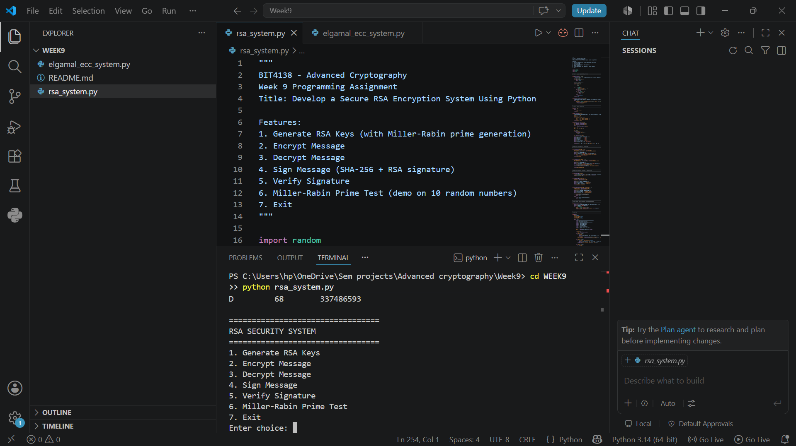

Encryption of text


Decryption of the text
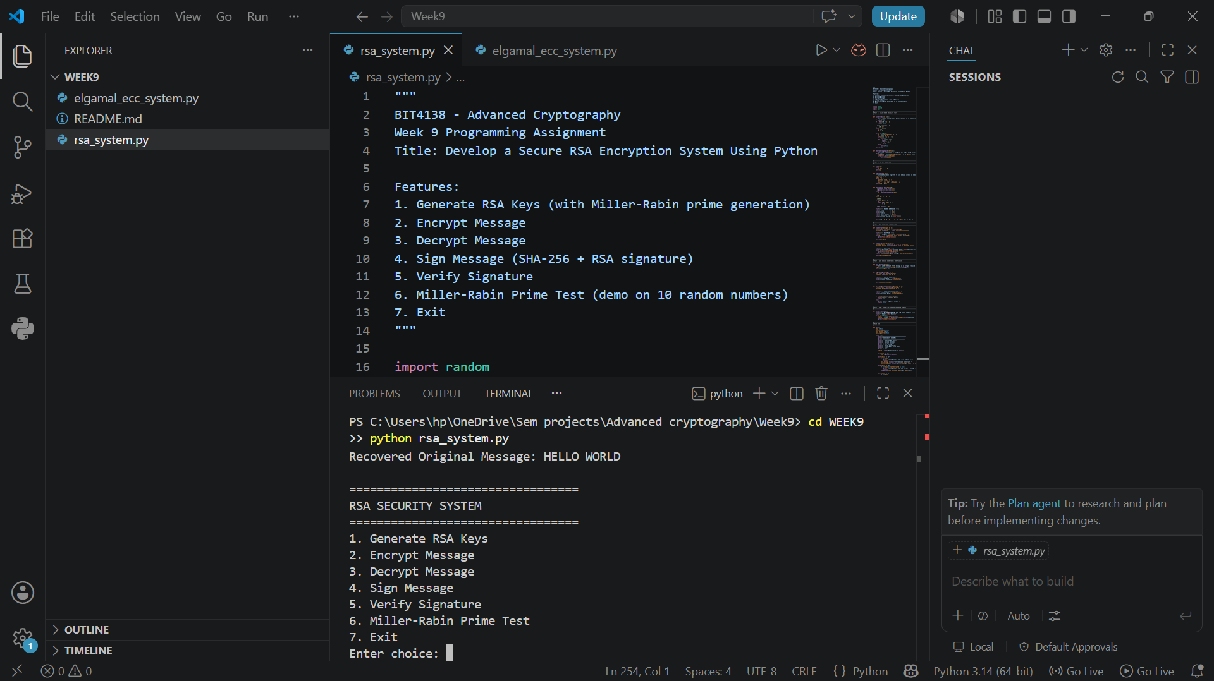

Digital signature of the encryption
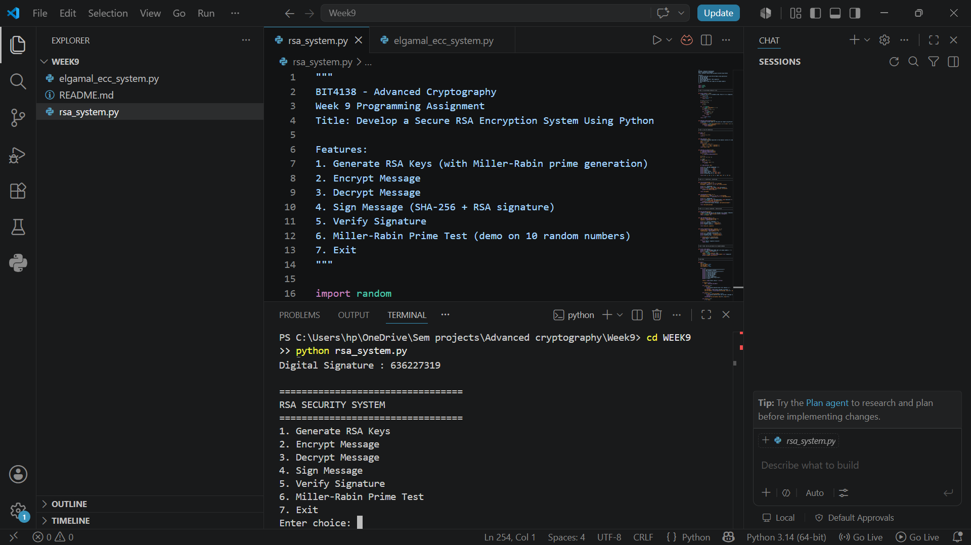

Miller-Rabin test
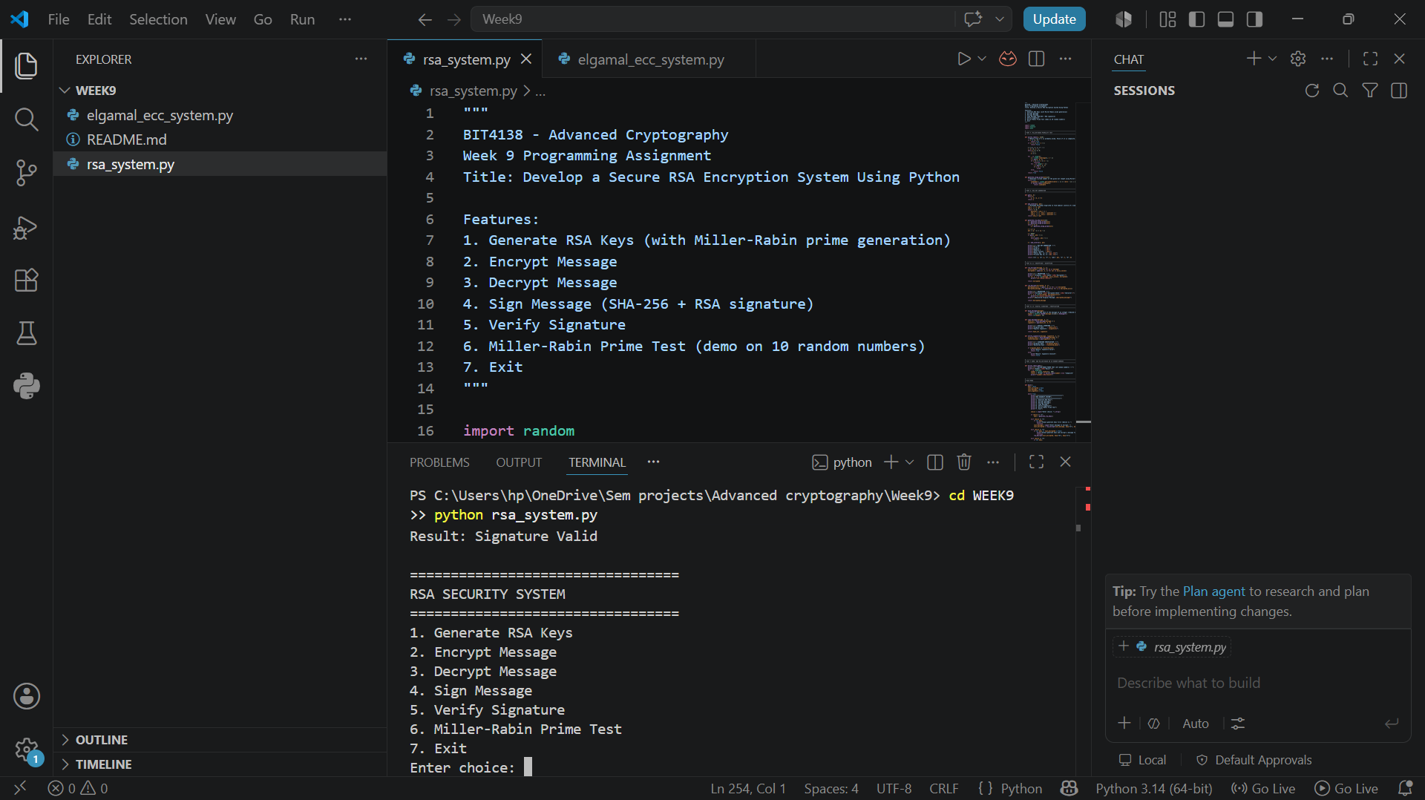
Reflection
This week I learned how RSA cryptography secures digital communication through key generation, encryption, decryption, and digital signatures. I also explored the Miller–Rabin primality test and improved my Python programming skills by implementing cryptographic concepts. The practical strengthened my understanding of public-key cryptography and secure message transmission.

WEEK 10 – ElGamal Cryptosystem

Key generation on Elgamal cryptosystem
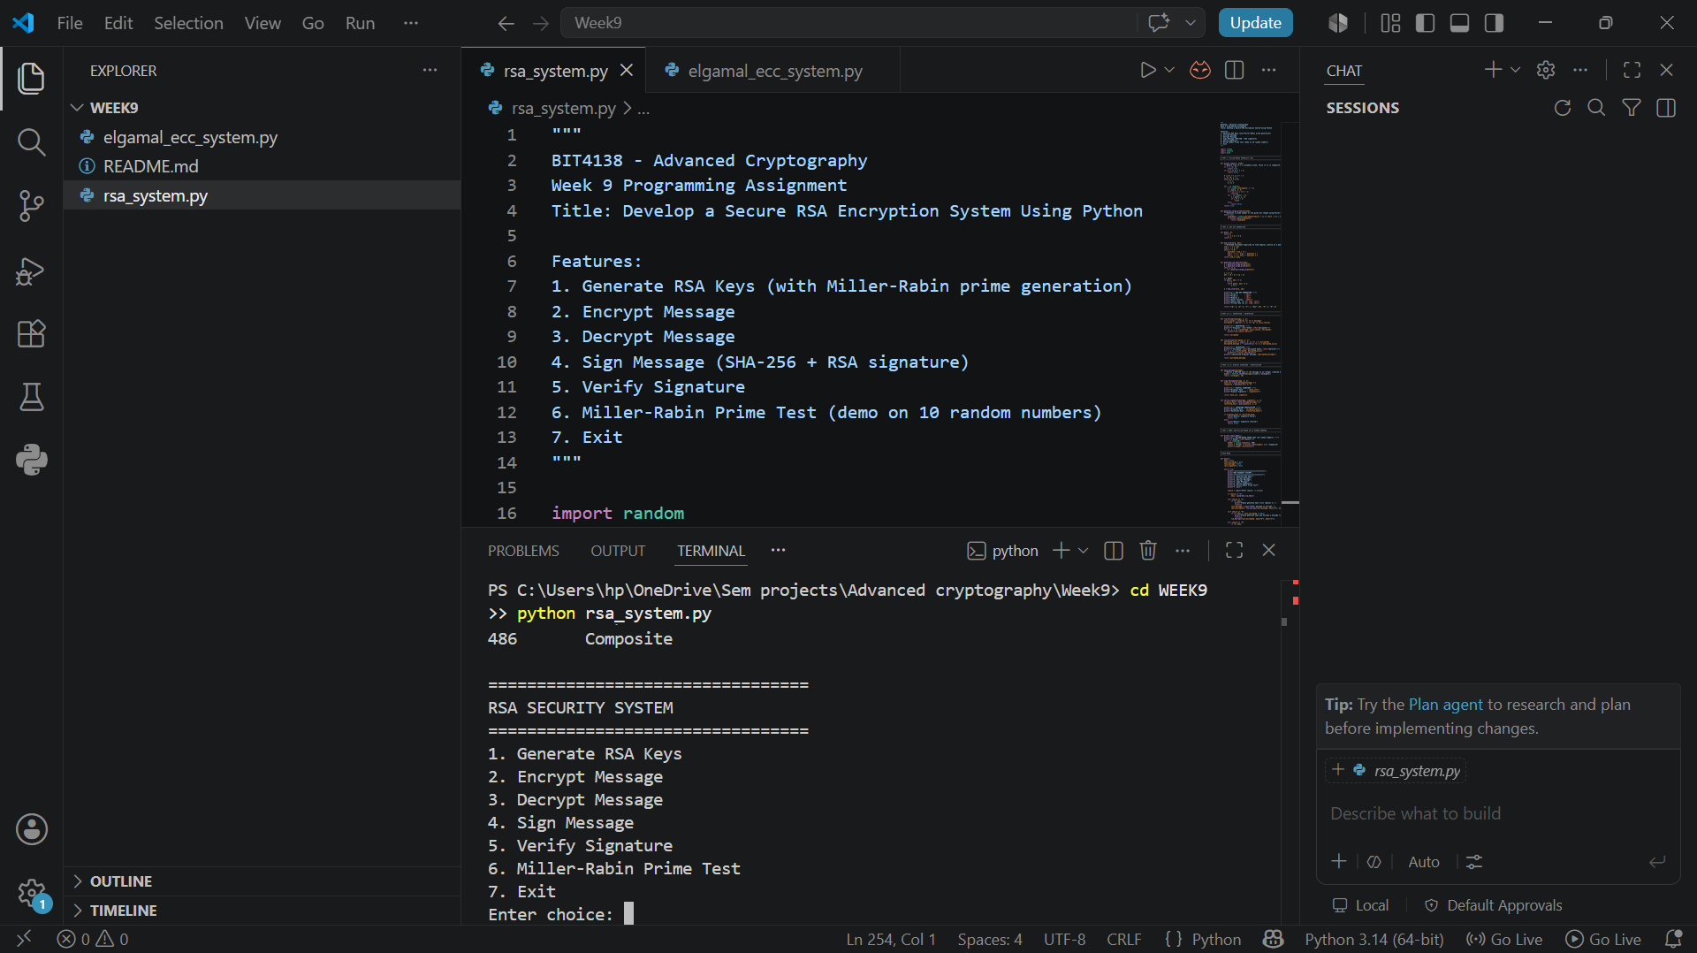

Encryption of text
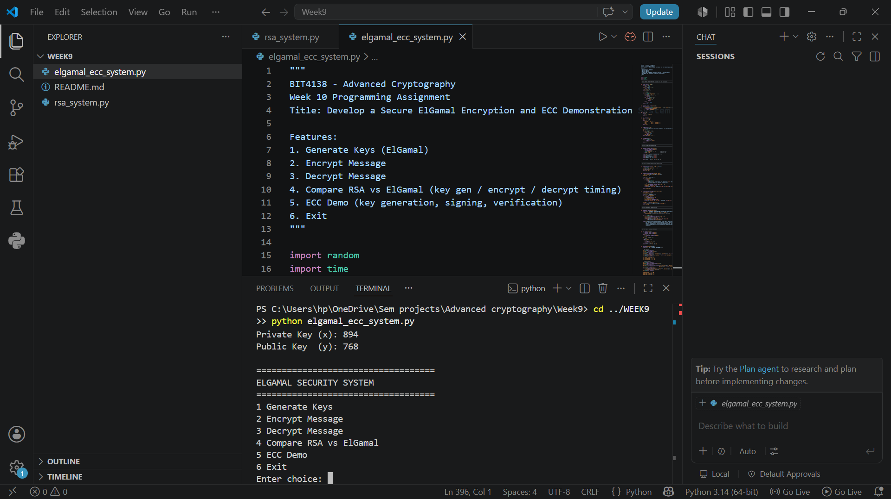

Decryption of text
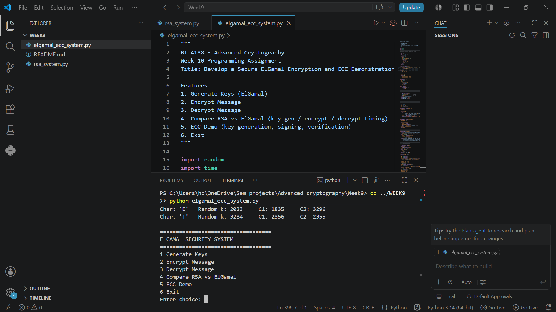

Randomness demonstration
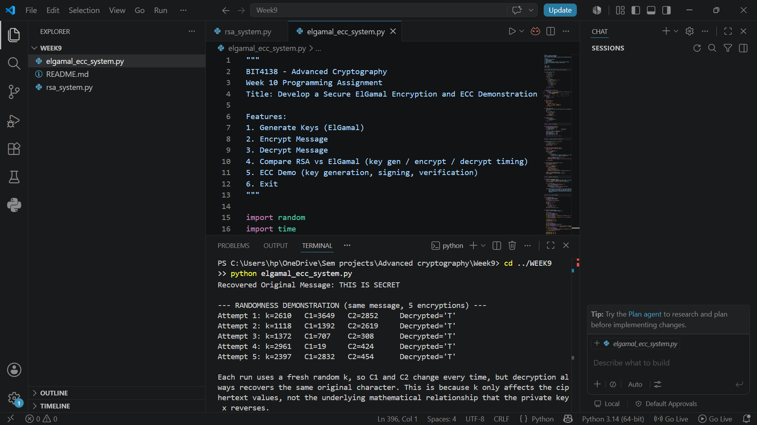

RSA vs ElGamal cryptosystems
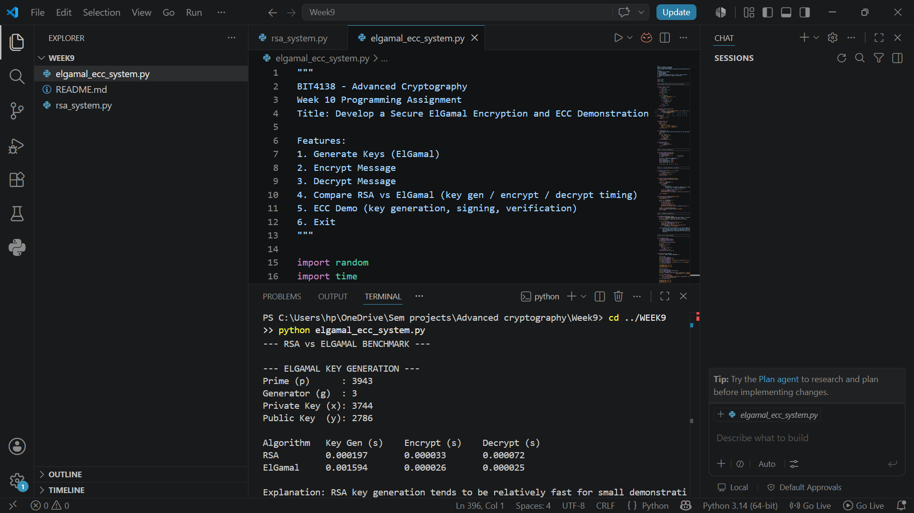

Reflection
This week I explored ElGamal encryption and Elliptic Curve Cryptography (ECC). I learned how ElGamal uses randomness for secure encryption and compared its performance with RSA. The practical improved my understanding of modern encryption techniques, key management, and the importance of efficient cryptographic algorithms.

